**Instructions for Home Access**

Type

<https://sra.st-gabriels.org.uk>

into your browser’s address bar – make sure its starts https

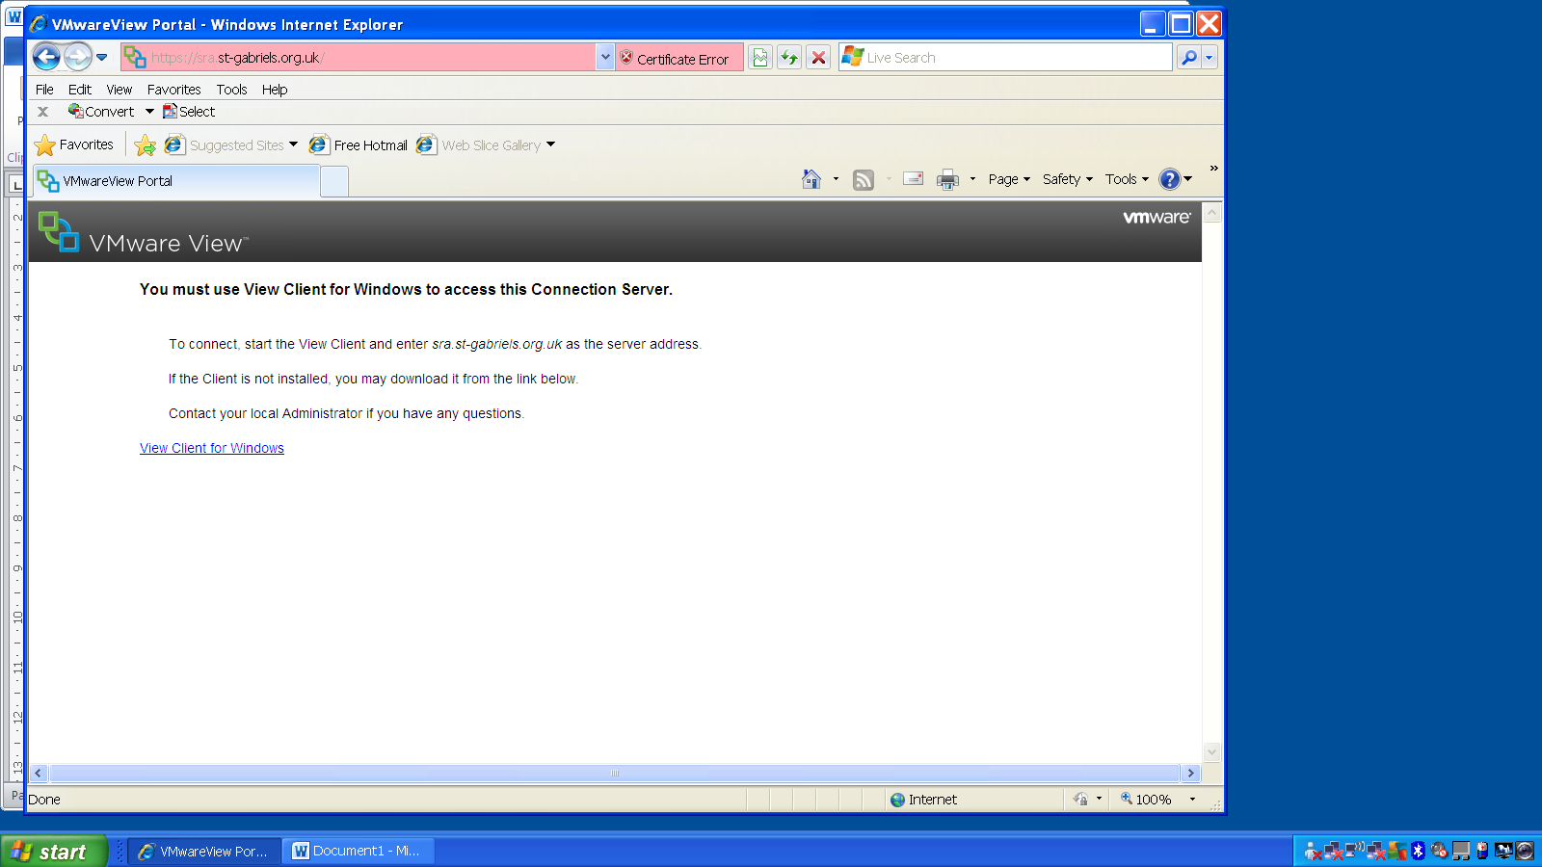

Click on View Client for Windows

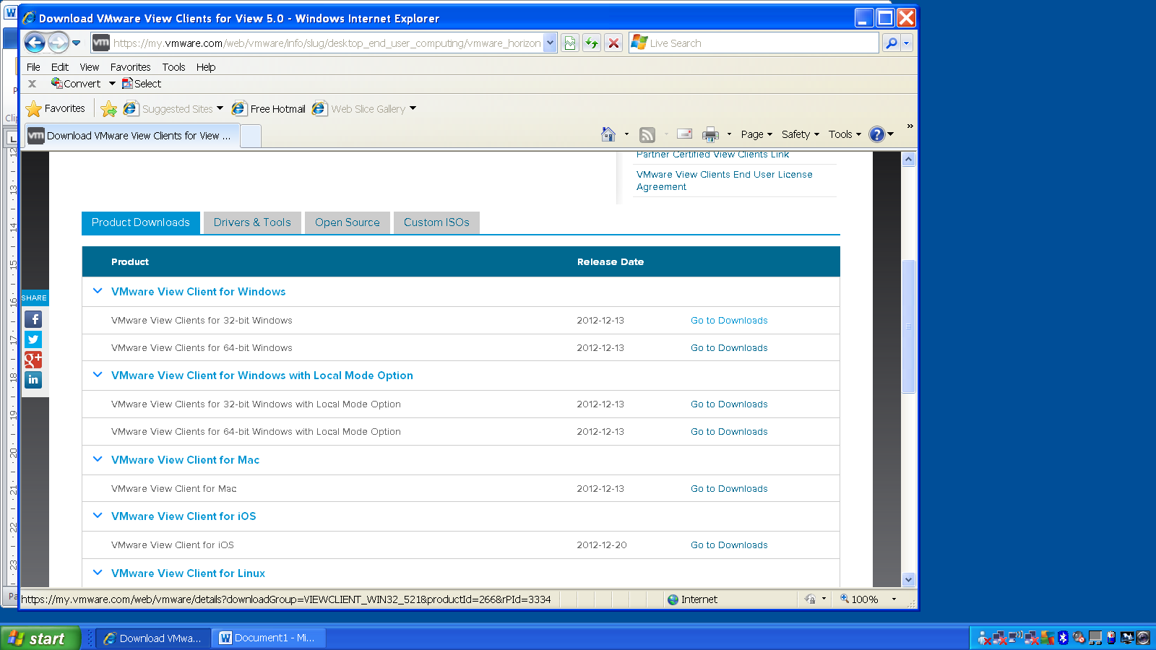

Choose the correct version for your computer – if you choose the wrong one it will tell you later that it is the wrong one.

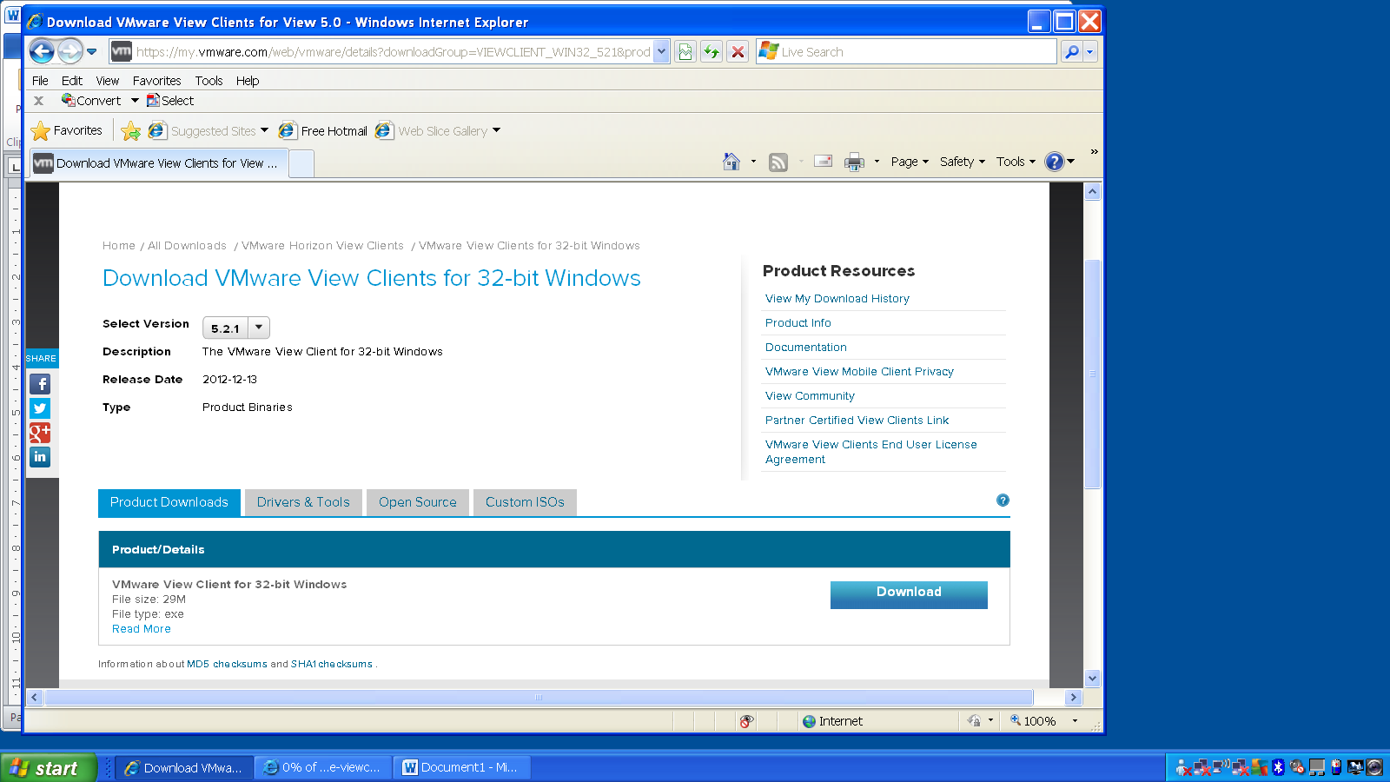

Press download when you have chosen the correct version.

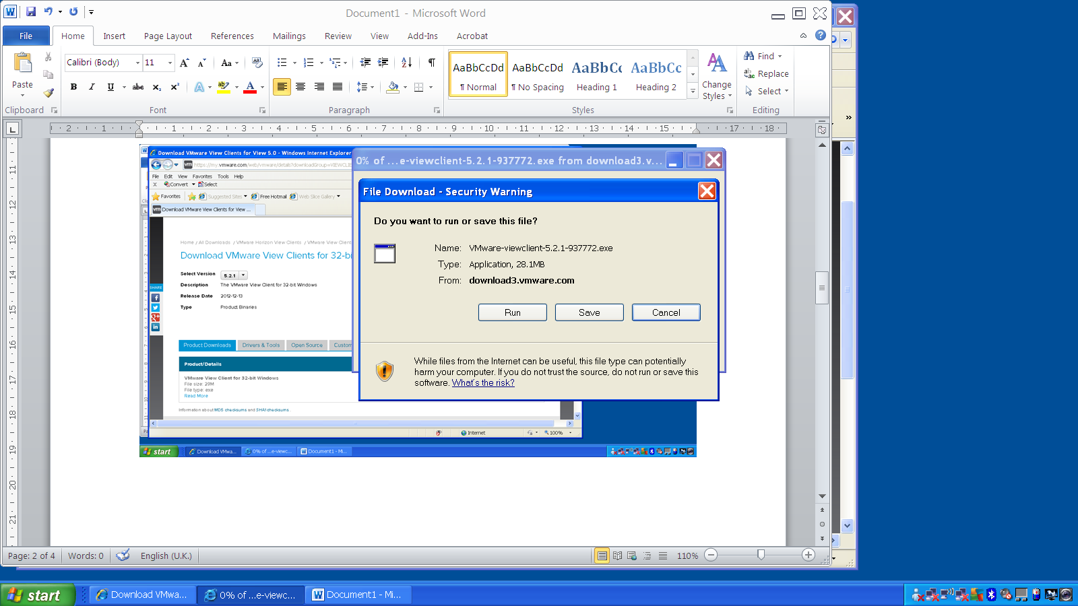

Press Run

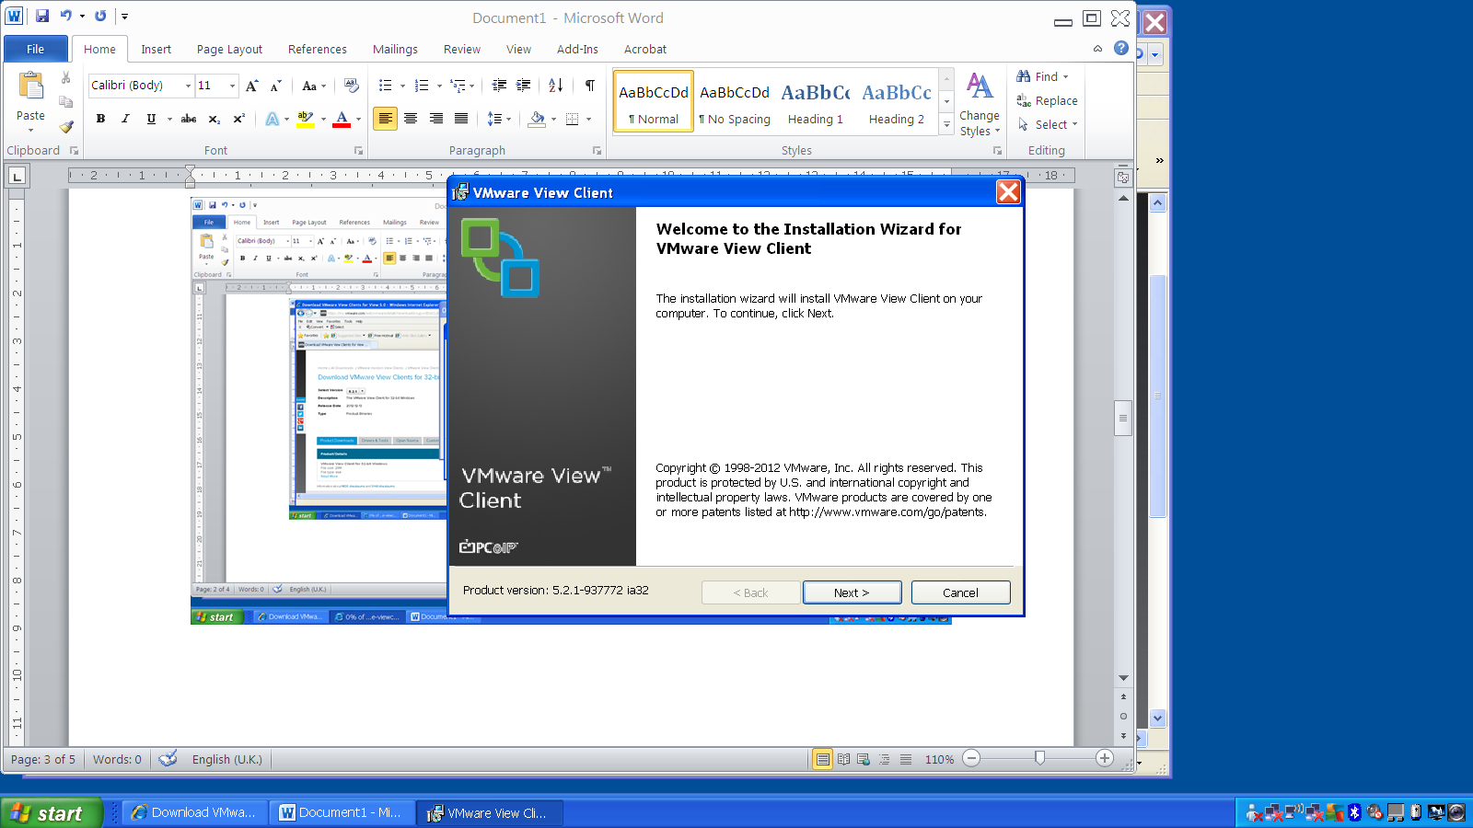

Press Next

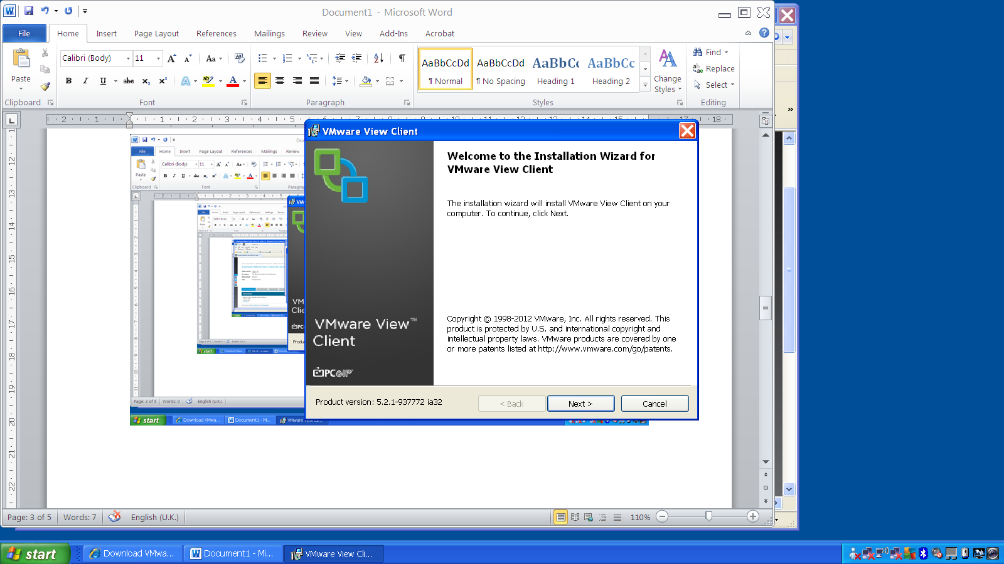

Next

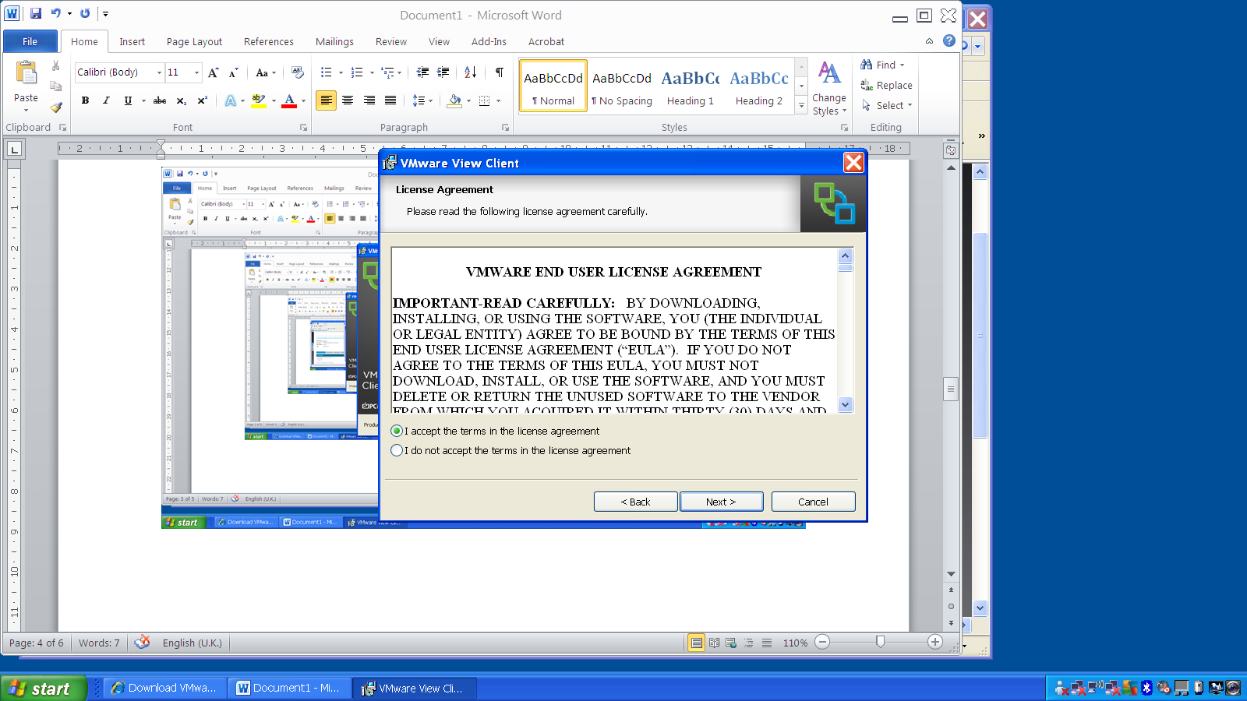

Next

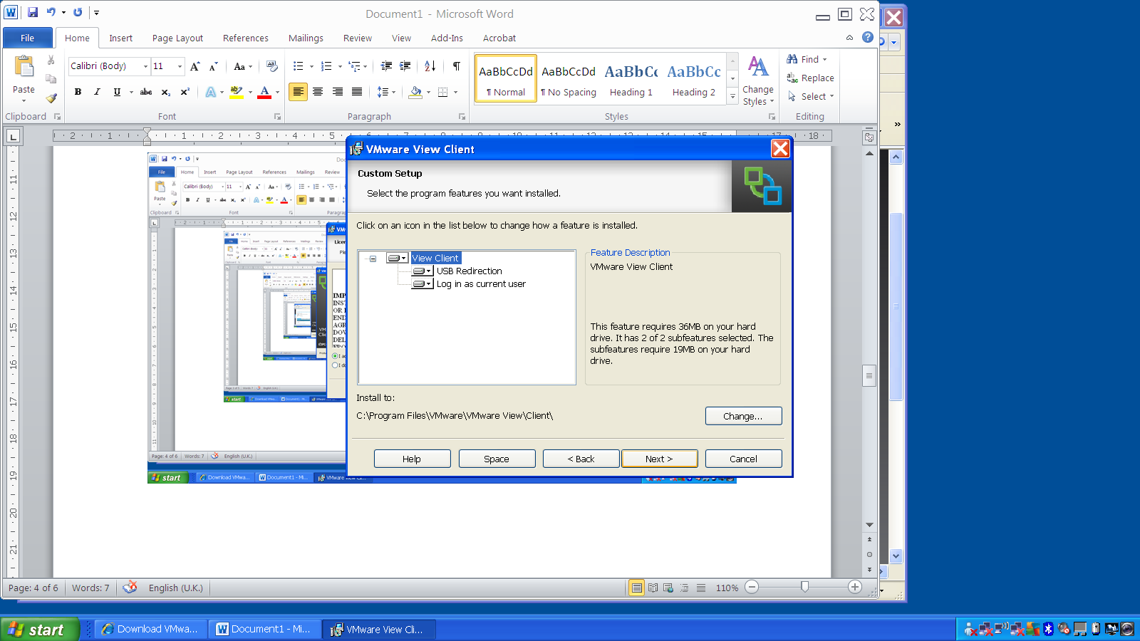

Choose View Client and press Next

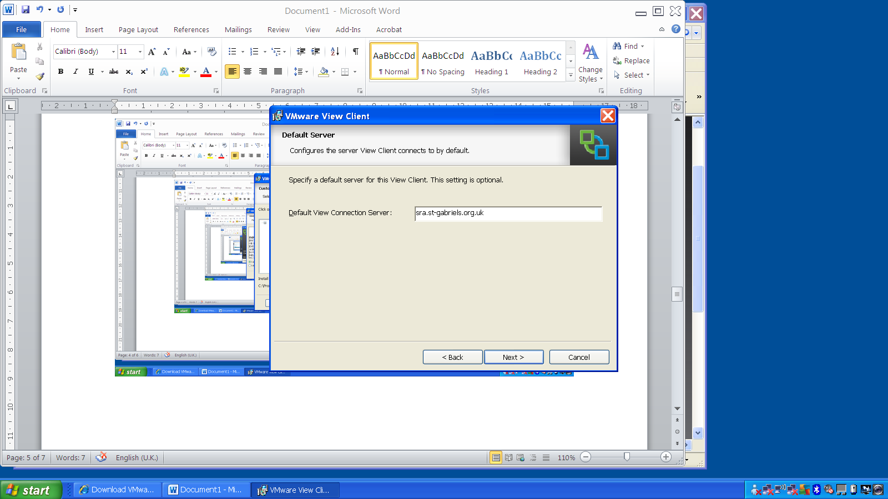

Enter the address

sra.st-gabriels.org.uk

then press Next

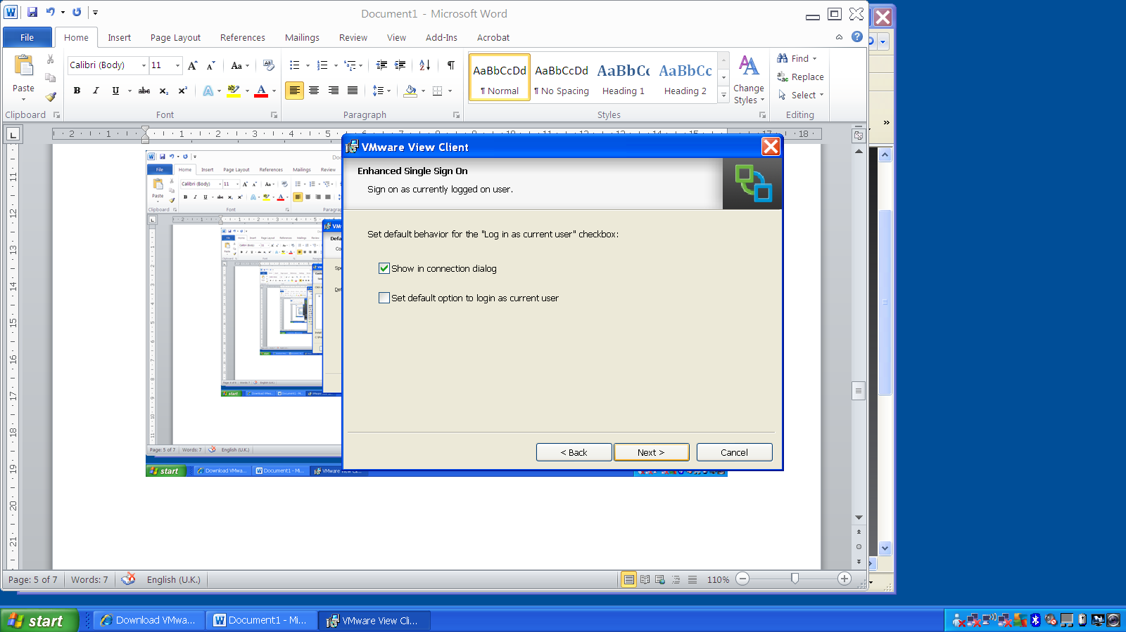

Tick Show in connection dialog

Press Next

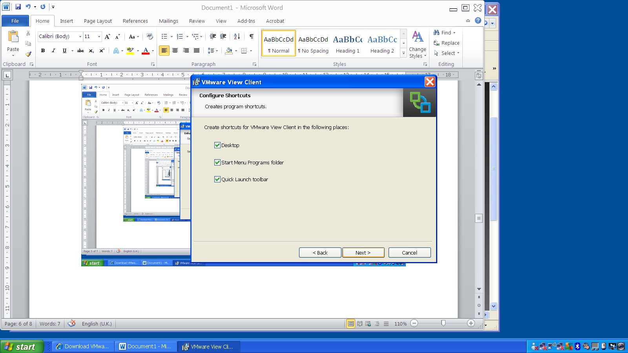

This is asking you to choose where you want icons to click on - choose the ones you want.

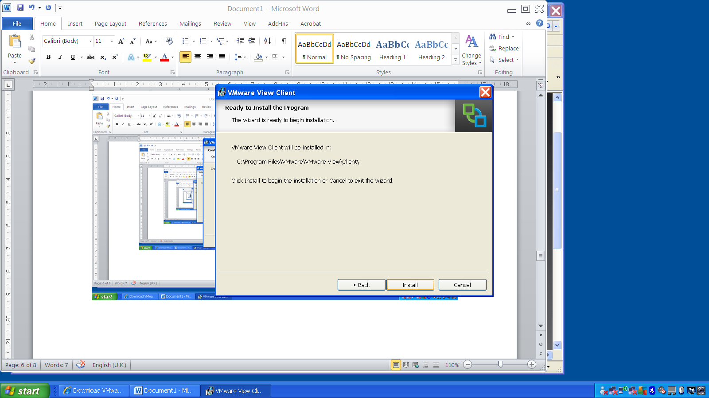

This is telling you where the program is on your computer.

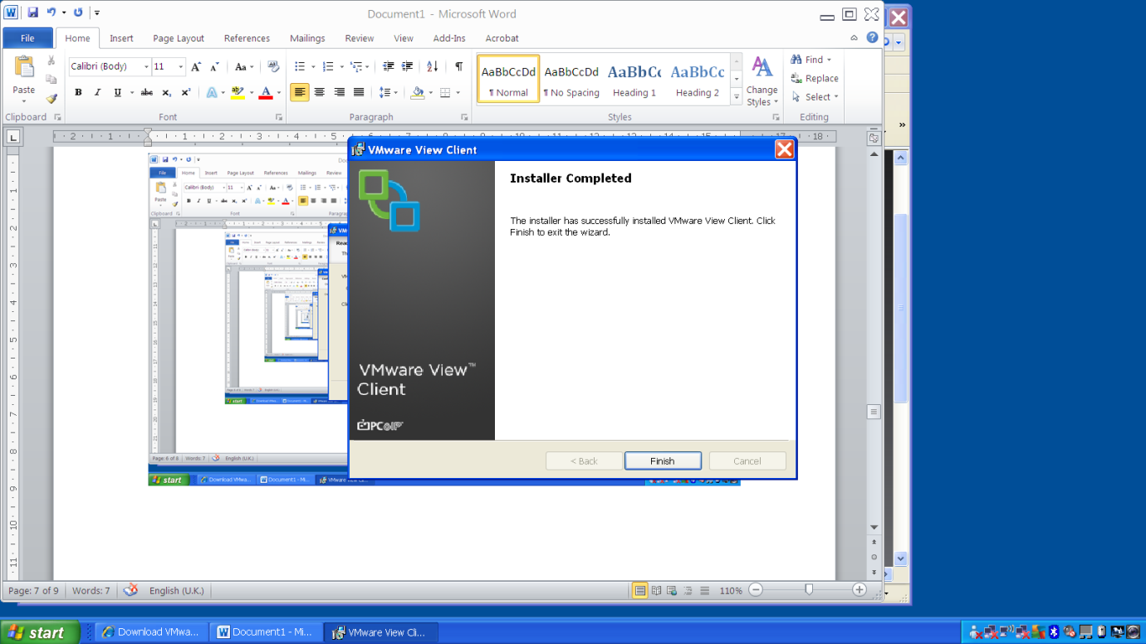

It has finished installing

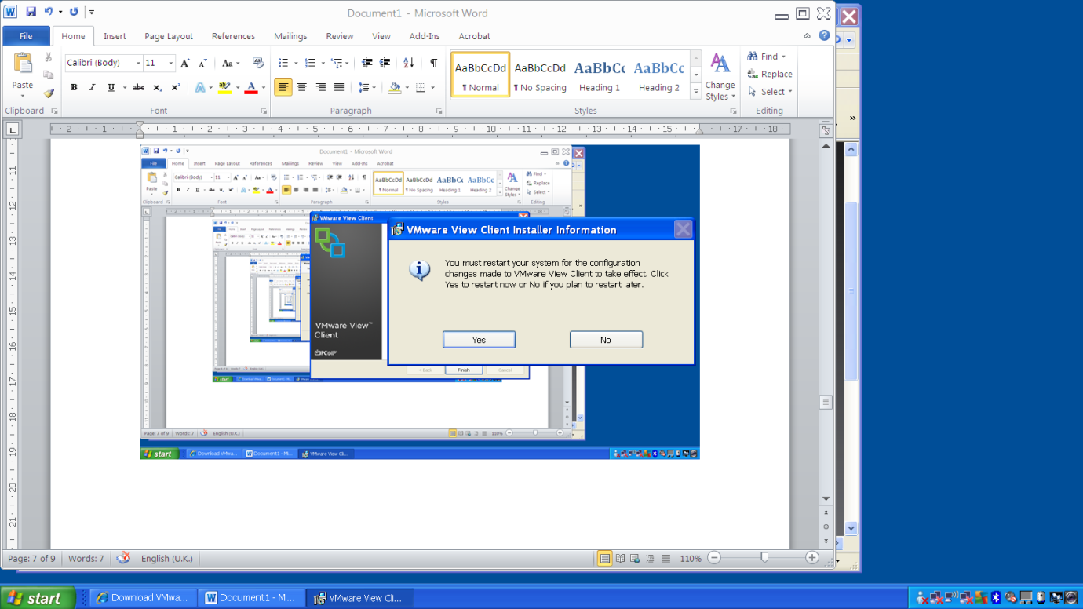

You need to restart your computer before it will work

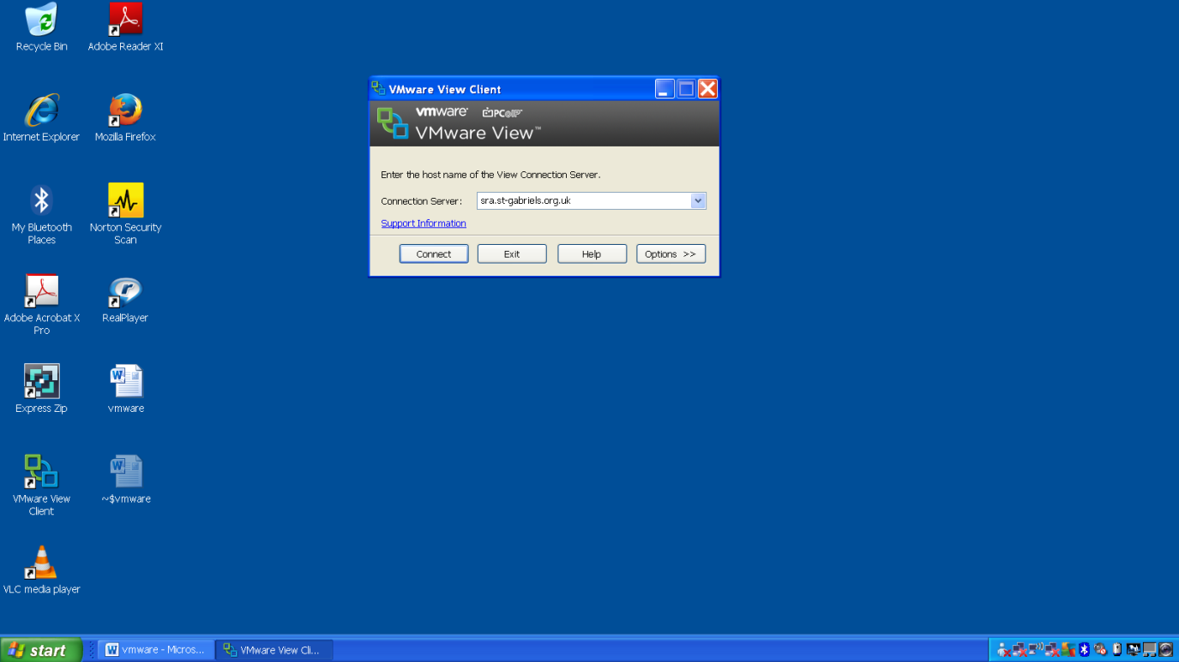

tart the program by clicking on the icon (the bottom on the left here)

Then press connect make sure the address is correct.

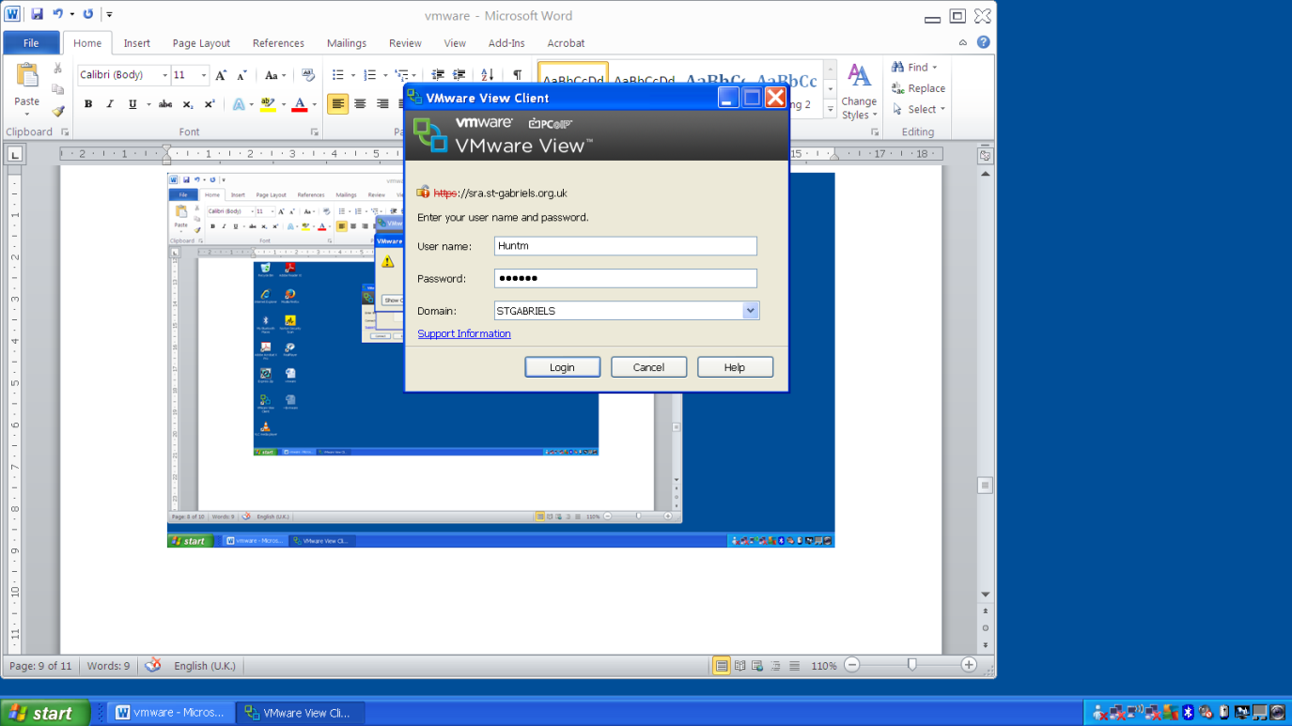

Enter your school user name and school password – make certain Domain says STGABRIELS

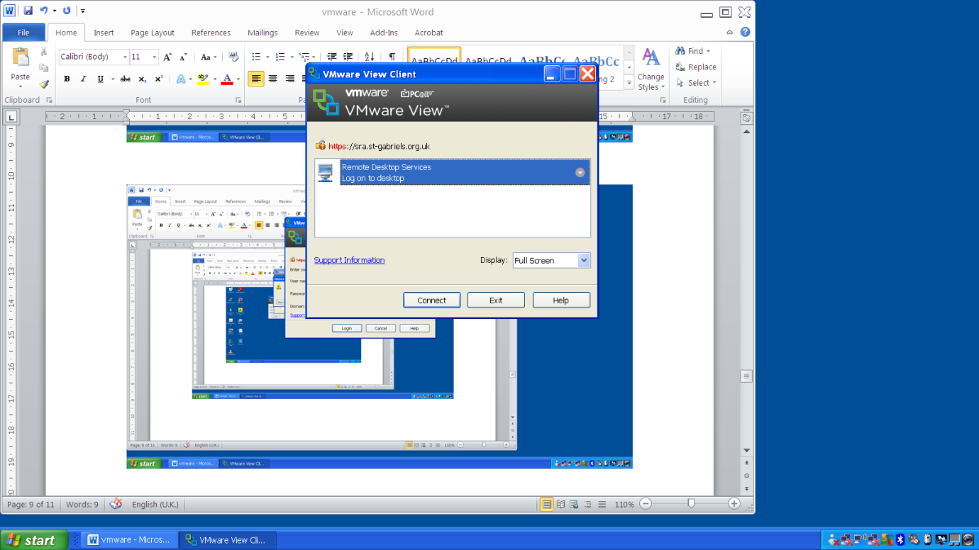

Press Connect