**The structure and functions of the cardio-respiratory system**

Diagram

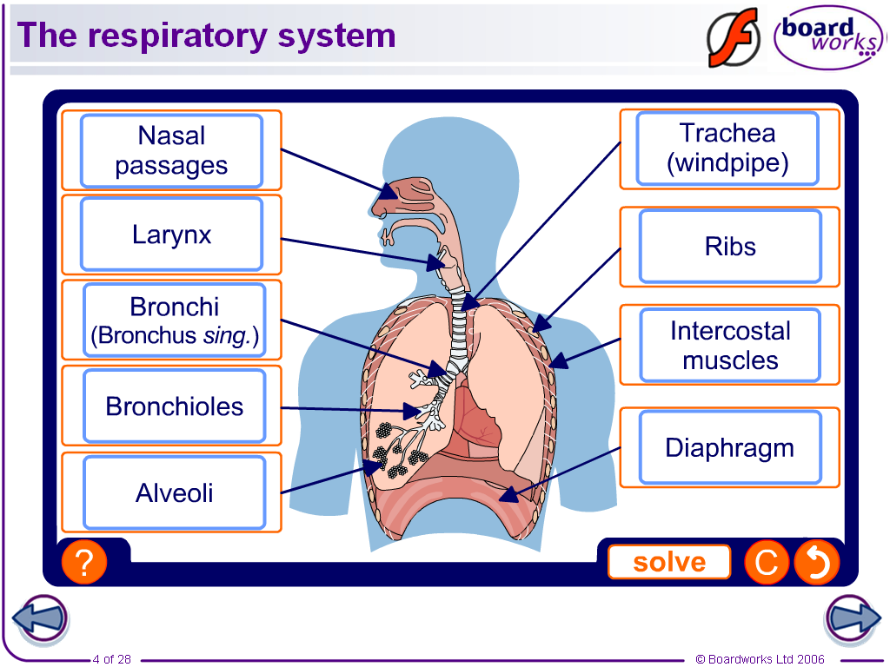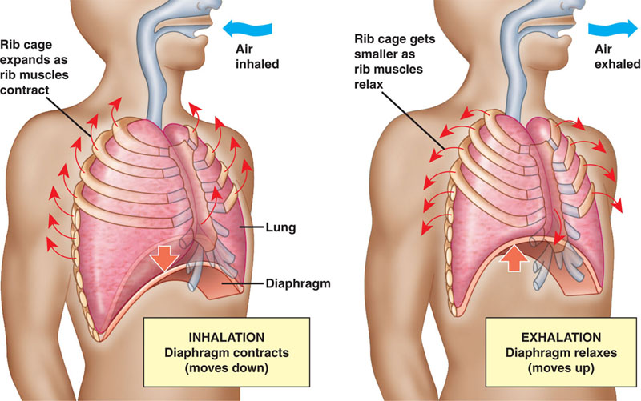

|  |  |
| --- | --- |
| **Inspiration (active) – during exercise** | **Expiration (active or forced) – during exercise** |
| 1. Diaphragm contract | 1. Diaphragm relaxes |
| 2. Diaphragm flattens with more force  Increased lifting of ribs and sternum | 2. Diaphragm pushed up harder with more force  Ribs / sternum pulled in and down |
| 3. Increased thoracic cavity volume | 3. Greater decrease in thoracic cavity volume |
| 4. Lower air pressure in lungs | 4. Higher air pressure in lungs |
| 5. More air rushes into lungs | 5. More air pushed out of the lungs  Features of Gas Exchange:  -thin walls (one cell thick)  -short distance for diffusion (short diffusion pathway)  -lots of capillaries  -large blood supply  -movement of gas from high concentration to low concentration.  -oxygen combines with haemoglobin in the red blood cells. |

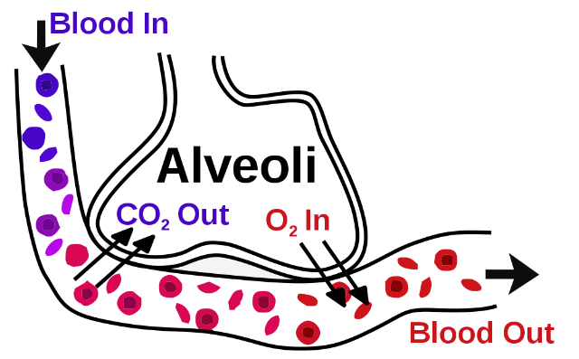

Gaseous exchange is the process where oxygen from the air in the alveoli moves into the blood in the capillaries, while carbon dioxide moves from the blood in the capillaries into the air in the alveoli.

These gases exchange by DIFFUSION.

DEFINITION: DIFFUSION - a process when substances move from a region where they are in **high** concentration to a region where they are in **low** concentration.

**Lung Volumes definitions**

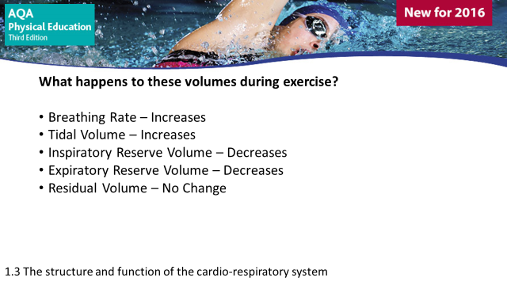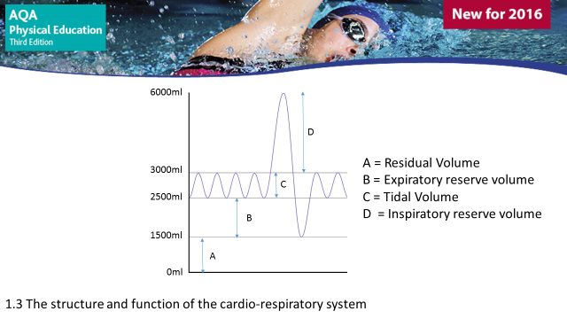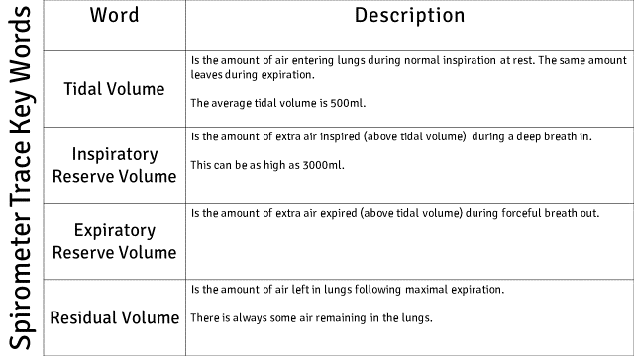

Spirometer Trace

Blood Vessels

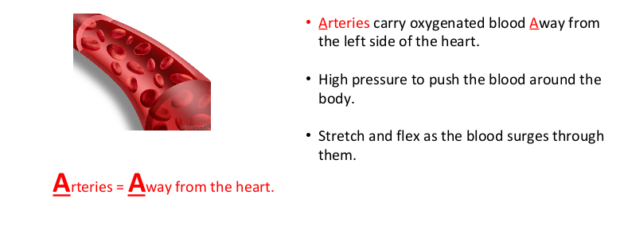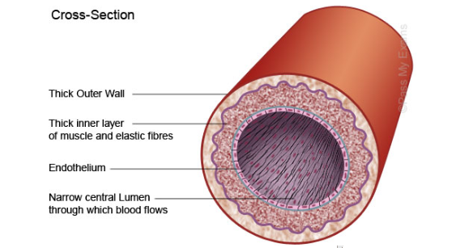

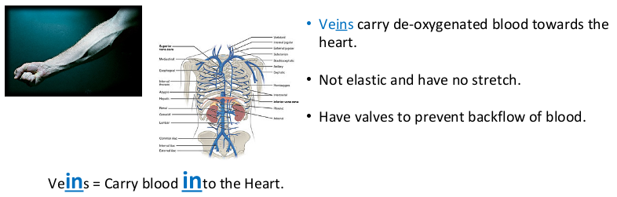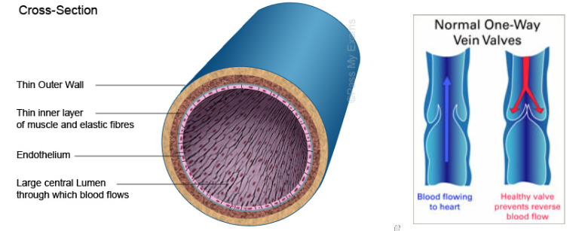

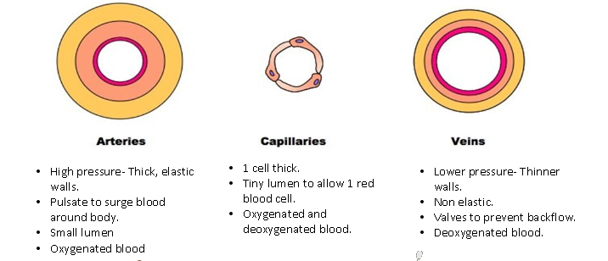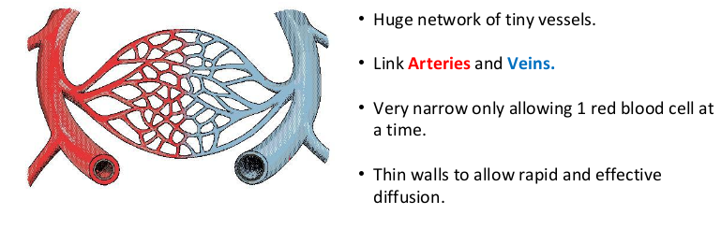

**3.1.1.2 The structure and functions of the cardio-respiratory system**

|  |  |  |  |  |
| --- | --- | --- | --- | --- |
| **Blood vessel** | **Drawing** | **Structure** | **Function** | **Special features** |
| Artery |  | Thick, elastic, muscular walls.  Small lumen/ diameter. | Mostly carries oxygenated blood **away** from the heart and around the body.  High pressure to pump the blood round the body. |  |
| Vein |  | Thin walls.  Large lumen/diameter. | Mostly carries deoxygenated blood **towards** the heart from the body. | **Valves** to prevent the backflow of blood – under lower pressure. |
| Capillary |  | 1 cell thick  Very narrow | Allows **diffusion** of oxygen/carbon dioxide and waste products at the muscles and lungs (Gaseous exchange). |  |

**Vasoconstriction** – ***Narrowing*** of the artery, which reduces the blood flow.

**Vasodilation** – ***Increasing*** the size of the artery, which increases blood flow. This happens during exercise to get more oxygen to the working muscles.

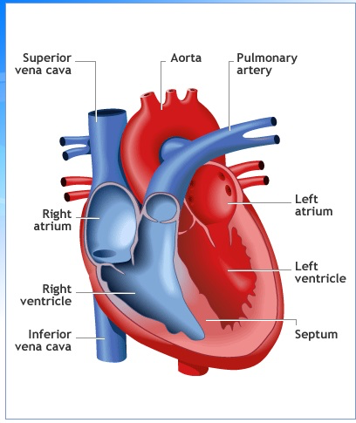

**The Heart**

**4 Chambers of the heart**

The heart also has **valves** to **prevent backflow** of blood.

* Left atrium
* Left ventricle
* Right atrium
* Right ventricle

**Arteries of the heart**

**Aorta** – Transports oxygenated blood round the body.

**Pulmonary artery** – Transports deoxygenated blood to the lungs.

**Veins of the heart**

**Vena Cava** – Transports deoxygenated blood to the heart from the body.

**Pulmonary vein** – Transports oxygenated blood to the heart from the lungs.

**The pathway of blood**

**OXYGENATED BLOOD DE-OXGENATED BLOOD**

Body

Left atrium

Left ventricle

Lungs

Vena Cava

Pulmonary vein

Body

Pulmonary artery

Right ventricle

Right atrium

Lungs

Aorta

**Key Terms**

**DIASTOLE** – Relaxation of the heart. The atrium fills with blood.

**SYSTOLE** – Contraction of the heart. The ventricles pump out blood.

**CARDIAC OUTPUT (CO)** – The volume of blood ejected from the heart in 1 minute. (L/min)

**STROKE VOLUME (SV)** – The volume of blood that leaves the heart each contraction (BEAT). (ml)

**HEART RATE (HR)** – The number of times the heart beats each minute. (BPM)

**Relationship between HR, SV and CO:**

**CO = SV x HR**

When we exercise our HR, SV and CO all **INCREASE**. This is because more **oxygen** is required for the **working muscles.**

**Heart Rate Graphs**

To get full marks you must:

1. Label both axis including measurements.
2. Make sure the points are plotted correctly and joined up.
3. Ensure you number the axis appropriately.

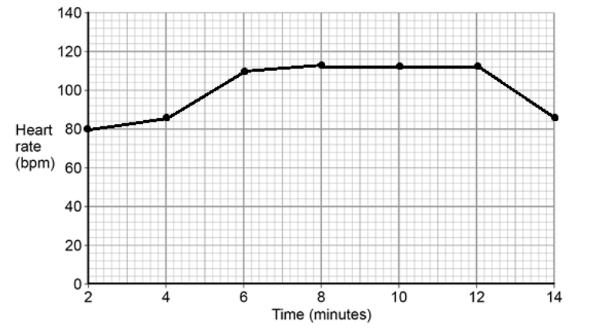

**Analysing the graph:**

Before exercise there may be an increase. This is called the ANTICIPATORY RISE. E.g. this will be between 2-4 minutes.

When the HR increases – the intensity will have increased. This could be the player starting to run quicker. E.g. 4-6 minutes.

When the HR plateaus (remains the same) – the intensity will have remained the same. This could be the player running at the same speed. E.g. 8-12 minutes.