**The structure and functions of the musculoskeletal system**

The skeletal system allows movement at a joint, the shape and type of the bones determine the amount of movement (short bones enable finer controlled movements/long bones enable gross movement) flat bones for protection of vital organs, the different joint types allow different types of movement, the skeleton provides a point of attachment for muscles – when muscles contract they pull the bone.

**There are 5 Functions of the Skeletal System:**

* **Support**

*The muscles and vital organs (such as heart and lungs). Without support the body would be a mass of soft tissue that was unable to move.*

* **Protection**

*Of vital organs such as cranium, a flat bone, protecting the brain. During physical activity, protection is crucial for both performance and long-term health. It reduces the chance of injury.*

* **Movement**

*Which occurs at joints when muscles contract and pull on the bone. The ability to move is central to all physical activities.*

* **Structural Shape and Points for attachments**

*For maintaining the basic form of our body and providing something for muscles to attach to. Without shape and structure we would not be able to move.*

* **Mineral Storage**

*Their role in physical activity is, therefore, linked to the general health of an athlete, which clearly affects sporting performance. (Such as calcium, which helps with bone formation)*

* **Blood Cell Production**

*This takes place in the bone marrow where red blood cells are formed. Red blood cells carry oxygen and white blood cells fight off infections,*

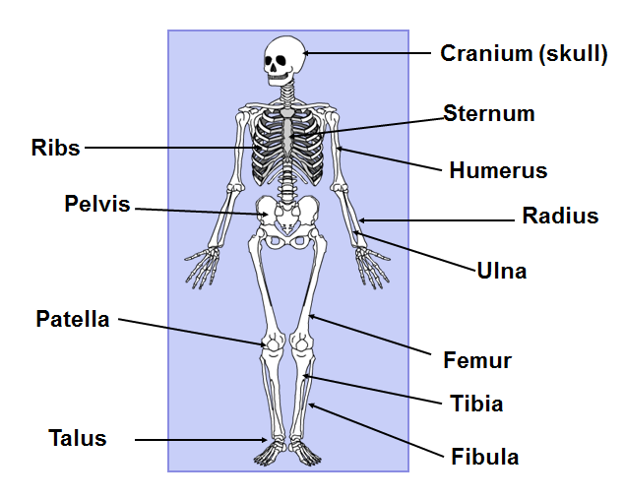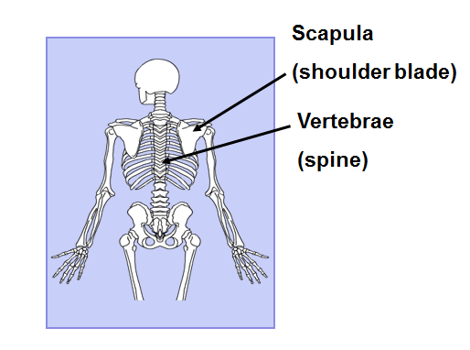

**The muscles in the body:**

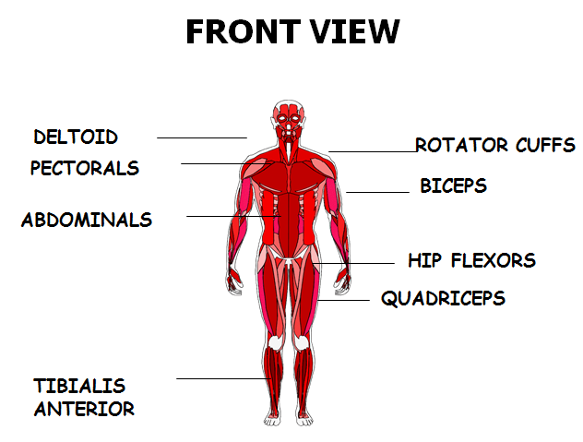 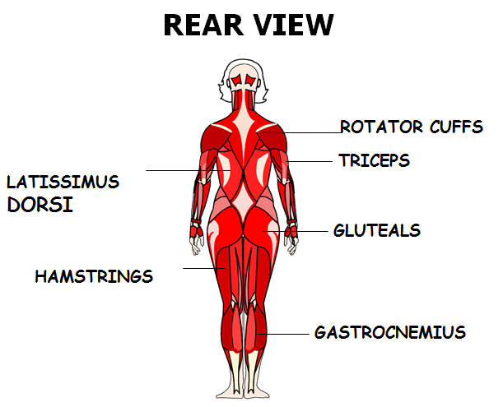

**The structure and functions of the musculoskeletal system**

**Structure of a Synovial Joint:**

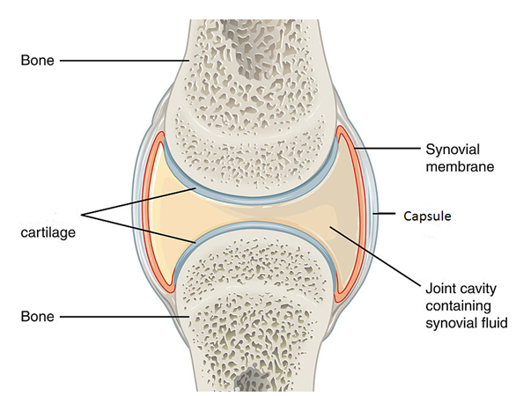 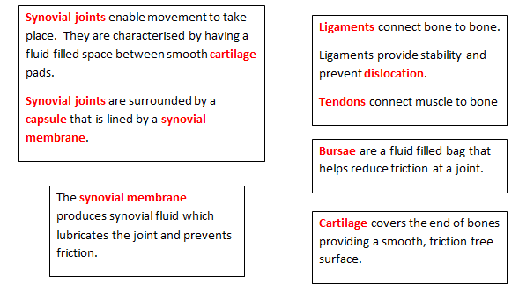

Types of Synovial Joints and their movements:

|  |  |
| --- | --- |
| Hinge joint | Ball and Socket |
| **Where:** Elbow/Knee/Ankle | **Where:**  Shoulder/Hip |
| Extension | Flexion |
| Flexion | Extension |
| **Ankle** | Adduction |
| Dorsiflexion | Abduction |
| Plantarflexion | Rotation |

**Muscles and movement:**

**The muscle that contracts is called the ‘Prime mover’ or ‘Agonist’.**

**The muscle that relaxes is called the antagonist.**

* **Muscles can only pull, not push. They are therefore arranged in pairs on either side of joints.**
* **One muscles contracts and pulls whilst the other relaxes.**

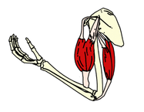

Types of Muscle Contractions:

**Isometric contraction:** Muscles **contract** and **no** movement is produced. i.e. Plank.

**Isotonic Contraction:** Muscles **contract** and **movement** is produced. Isotonic contractions can be **concentric** (where the muscles contracts and shortens) or **eccentric** (where the muscles contracts and lengthens, usually in the downwards phase of a movement)

**The following muscles make up obvious antagonistic pairs:**

* **Biceps and triceps- acting at the elbow to create flexion and extension.**
* **Hip flexors and gluteals, acting at the hip to create flexion and extension.**
* **Hamstring and quadriceps, acting at the knee to create flexion and extension.**
* **Tibialis anterior and gastrocnemius, acting at the ankle to create dorsiflexion and plantar flexion.**